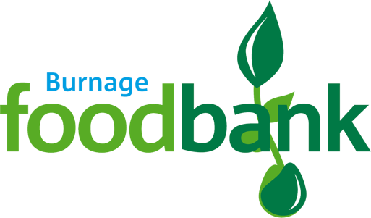
Standing Order Mandate
Burnage Foodbank

Please return or email this form to the foodbank, using the foodbank’s details below. We will save a copy for our records and pass a copy onto your named bank or building society.
Postal Address: Burnage Foodbank, St Bernard’s Church Burnage Lane, Manchester, M19 1DR.
Email Address: info@burnage.foodbank.org.uk (you will need to sign and scan a copy back if emailing).

Your bank details:
Name of bank
Address
Town
Postcode
Sort Code xx-xx-xx
Account Number xxxxxxxx
Your gift: I would like to donate the sum of
Amount in numbers
Amount in words
On the DD/MM/YYYY
Frequency | Week/Month/Year (please delete those that don’t apply)
My details
Title
First Name
Last Name
Address
Town
Postcode
Email Address
Boost your donation by 25p of Gift Aid for every £1 you donate
Gift Aid is reclaimed by the charity from the tax you pay for the current tax year.

In order to Gift Aid your donation you must tick the box below:
I want to Gift Aid my donation above to Burnage Foodbank, I am a UK taxpayer and understand that if I pay less Income Tax and/or Capital Gains Tax in the current tax year than the amount of Gift Aid claimed on all my donations it is my responsibility to pay any difference.

Signed…………………………………………………………………………… Date………………………………………..

We would love to keep you up to date with information about Burnage Foodbank. Please tick the box if we can keep you updated by email:

Burnage Foodbank is committed to protecting your privacy and will process your personal data in accordance with current Data Protection legislation. Burnage Foodbank collects information to keep in touch with you and supply you with information relating to our work.
You can opt out by emailing us at info@burnage.foodbank.org.uk

