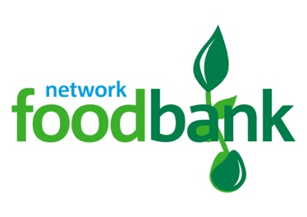
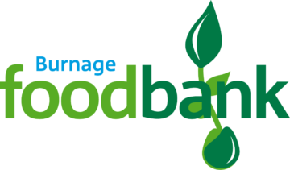
c/o St. Bernard’s Church,
Burnage Lane
Burnage,
Manchester,
M19 1DR
Tel: 07796 448 205
Email: info@burnage.foodbank.org.uk
Website: www.burnage.foodbank.org.uk

Privacy Notice for People Referred to Foodbanks

Personal Information
When you come to a food bank for help, the food bank will keep some information about you. This is “personal data”, because it is about you as an individual, and it can be linked to you. The food bank is responsible for looking after your personal information, known as the data controller, we’re registered with the Information Commissioners Office ZA315577

If you have any questions about anything in this notice, you can contact Heather Green project manager on 07796 448 205 or email manager@burnage.foodbank.org.uk

What personal data do we hold?
The food bank will keep the data that is on your foodbank voucher(s) including your name, address, and year of birth; information about your household including the number of other adults and children living with you; the reason you were referred. We will also keep a record of who gave you the foodbank voucher, where you give permission any dietary requirements, and a phone number; so we can contact you about the support we can offer.

The organisation that referred you may have also asked you about your ethnicity. We use this information to help us to better understand if we’re meeting the needs of different groups in our communities. This is sensitive personal information, and we need your permission to hold it. You can choose not to provide this information and it won’t affect the help you receive in any way. Once you collect your parcel this information is anonymised (so that it can’t be linked to you).

What is your data used for?
We only ask for information about you that we need. The reasons we need your information include:
- To provide you with the help and support you’ve requested.
- To report on the reasons why people need our help, and the support we’ve provided.
- If you’ve needed help from the food bank more than once, we use this information understand if you need other help, such as help maximising your income. In this situation we may be able to offer support directly, or with your permission, refer you to another organisation who can help.

Does the food bank have a right to your data?
Under UK Data Protection law, we need a “lawful basis” for using your personal information.
The food bank has a “legitimate interest” to use information you provide to offer you the help you’ve requested, and to evidence why people needed our help, and the support we’ve given.

In some situations, we need your “consent” to use your information. For example, where you agree to providing a phone number so we can contact you about the support we’re providing or where you provide information about your ethnicity.

Who can see your data?
Your personal information is only seen by people who need to do so for food bank reasons. It is not used for any other purpose. Your information is accessible to authorised people from this food bank. If you go to a different food bank in the Trussell Trust Foodbank Network, then authorised people from both food banks will be able to see your information – including your visits to the other food bank(s).

Agencies who refer you to a food bank using an on-line system called “e-referral” can see information about you and your visits to the food bank. If an agency with access to e-referral performs a successful search for someone with your name and postcode, they can see the date you last accessed help, but they can’t see any more detail, like your address or why you needed food bank help unless they refer you.

Your personal information is stored in a secure database run by the Trussell Trust, who are a separate data controller. The Trussell Trust is a data controller registered with the UK Information Commissioner’s Office registration number Z279027X. The Trussell Trust uses your information for statistical, research and monitoring purposes to campaign for a future where no one needs to use a food bank.

The Trussell Trust uses trusted suppliers to help run and manage the system. Where the Trussell Trust works third parties, they have contracts or agreements in place to ensure your information is kept safe. For more information about how the Trussell Trust protected your information please visit https://trusselltrust.org/privacy

How long will your data be kept?

Your personal information kept for six years after the date you last received a food parcel.
After six years, identifiable information about you, like your name and address, are removed from the database. This is known as anonymisation as the data can no longer be linked to you. We keep this information so we can effectively report on how the need for food banks has changed over time. We also need to show we have acted properly as a charity and used people’s donations in the right way.

What rights do you have?

Under UK Data Protection legislation, you have several rights, including to:
- Ask us for a copy of your personal information. There are some exemptions, which mean you may not always receive all the information we process.
- Tell us to change or correct your personal information if it is incomplete or inaccurate.
- Ask us to restrict our processing of your personal data or to delete your personal data if there is no compelling reason for us to continue using or holding this information.
- Receive from us the personal information we hold about you which you have provided to us, in a reasonable format specified by you, so that you can send it to another organisation.
- Object, on grounds relating to your specific situation, to any of our processing activities where you feel this has a negative and disproportionate impact on you.
To exercise your rights please contact Heather Green project manager on 07796 448 205 or email manager@burnage.foodbank.org.uk

