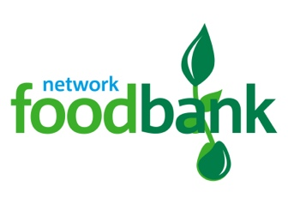
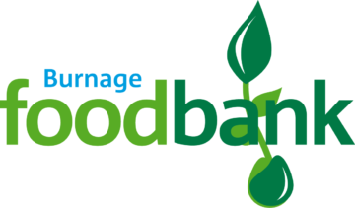
c/o St. Bernard’s Church,
Burnage Lane
Burnage,
M19 1DR
Tel: 07796 448 205
Email: referrals@burnage.foodbank.org.uk

Data Privacy Notice for Referral Agencies

Personal data
When your organisation becomes a referral partner for the foodbank, the foodbank will keep some data about you. This includes some “personal data” which relates to particular named people.
We also keep data about clients you refer to the foodbank. There is a separate Data Privacy Statement for Clients. Please ask if you would like to see a copy of that Data Privacy Statement.

What personal data do we hold?
The foodbank will keep data about you in two ways:
1) the registration form you filled in to become a referral agency to complete paper red vouchers.
this records the name, address, email address, phone number, and name of principal contact at your
organisation; and the name, signature and role of personnel authorised to issue foodbank vouchers.
2) our on-line data system
this records the name, address, email address, phone number, and name of principal contact at your
organisation; and the name, job title and email address of any personnel authorised to make e-referrals
to the foodbank
This is the only data the foodbank will usually hold about you. We do not get data about you in any other way.
There may also be information about you in emails.

How is your personal data kept safe?
Your registration forms are held in a locked cabinet. The key is only available to the Project Manager.
The digital data is kept in a secure on-line database. This can only be accessed with a login and password.
We require all users of the system to sign a “data protection statement”. This means they know they must keep your data safe, and only use it for the right purposes.
All our other volunteers also have to sign a confidentiality agreement.
We are as careful as possible to make sure no unauthorised person can log into the data system. For example, when a volunteer leaves the foodbank, we stop their access to the data system.

What is your data used for?
Your data is only used to
- Validate signatures on red vouchers your organisation has issued.
- Contact you if there is an important query about a client you have referred to the foodbank
- Send you replacement red vouchers if you cannot use the E-referral system.
- Keep in contact with you, for example to seek a meeting or invite your organisation to an event.

Does the foodbank have a right to your data?
Under Data Protection legislation, the foodbank needs to have a “lawful basis” for keeping your data, and for using it. There are several types of “lawful basis”. One of them is called “performance of a contract”.
When you become a referral agency foodbank, we enter into a “contract” together. You undertake to send people in genuine crisis to the foodbank with a completed voucher; we undertake to provide them with emergency food, and contact you if there is a problem. To do this, we need to hold data about you.
That is why the lawful basis for holding your data is “performance of a contract”.

Who can see your data?
The only people who have access to your application forms are the Project Manager and foodbank staff.
Your data on the on-line system can only be seen by authorised people who have been given a login and password for the data system.
We are as careful as possible to make sure no one else has access to your data.

How long will your data be kept?
Your application form will be kept while you are a referral agency for the foodbank.
If you stop being a referral agency, we will destroy your application form and any other signatories’ forms.
We will also delete you from the online data system as an active referral agency.
The on-line data system also records data from all foodbank vouchers. These will continue to show the name of the agency and the agency worker that issued a voucher, and their contact phone number. This is also recorded on the printed vouchers. These are kept for six years in case we need to evidence proper use of public donations.

Who can you speak to if you have questions?
If you have questions about your data, and what we do with it, you should contact Heather Green, Project Manager, Email: referrals@burnage.foodbank.org.uk Tel: 07796 448 205.

What rights do you have?
You have a number of rights under Data Protection legislation:
- Right to be know what data we hold
You have a right to know what personal data we hold about you.
This Data Privacy Statement describes the data that we will hold. But you can ask if we have any other data about you which is not covered by this Data Privacy Statement.
- Right to have a copy of the data we hold
You can ask for a copy of the data we hold about you. This is called a “subject access request”.
If you make a “subject access request”, we will give you a copy of all the data we hold about you.
We will do this within one month. If it helps, we will give you the data in a computer file.
- Right to object
You can object if you think we are using your data in the wrong way.
You can also object if you think we don’t have “lawful grounds” for using your data.
We will give you a statement explaining why we use your data and explaining the “lawful grounds”.
If you are still not happy, you can complain to the Information Commissioner’s Office.
If we find we are using your data in the wrong way, we will stop immediately and stop it happening again.
- Right to have your data corrected
If you think there is a mistake in your data, please tell us. You have a right to have it corrected.
We may need to check what is the correct data, but will put right any mistakes as soon as possible.
- Right to be forgotten
We promise to remove your data after six years. You have a right for this to happen, because we don’t need to keep your data any longer than six years.

Finally, if anything happened to your data that could be a risk to you, we will do our best to tell you.

